Name: Roll no: Section:

**SIR SYED UNIVERSITY OF ENGINEERING & TECHNOLOGY**

**COMPUTER SCIENCE & INFORMATION TECHNOLOGY DEPARTMENT**

**Fall 2023**

**Applied Physics (MS-111T)**

**QUIZ 1A**

Semester: I Batch: 2023F

Max Marks: 02

Instructions:

* Attempt all questions

Question 01

Fig: 01 shows portion of two large sheets of charge with uniform surface charge densities of:

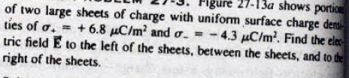

Find the net electric field between the sheets.

